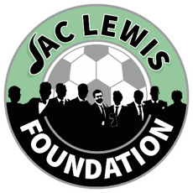

  - City Cluster Counselling Service
  - FREE Pain Management Workshop
- Our pain workshop is designed to provide a compassionate and supportive environment where individuals can find solace and strength in the company of others who understand their struggles.
- We believe that healing begins with understanding, and our workshop offers a safe space for participants to share their experiences, learn effective coping strategies, and build a network of support.
- Our sessions are facilitated by experienced professionals who are dedicated to helping you navigate the complexities of pain.
- Through a combination of guided discussions, therapeutic exercises, and mindfulness practices, we aim to equip you with tools that can make a tangible difference in your daily life.
- We understand that every individual's experience with pain is unique, and our approach is tailored to address the diverse needs of our participants.

  - 20th August 2024 10-12pm
Online - Via Zoom
To book onto the workshop please:
Email Admin@jaclewisfoundation.co.uk
Call or Text 03301336510

